**Business Problem**

In recent years, City Hotel and Resort Hotel have seen high cancellation rates. Each hotel is now dealing with a number of issues as a result, including fewer revenues and less than ideal hotel room use. Consequently, lowering cancellation rates is both hotels' primary goal in order to increase their efficiency in generating revenue, and for us to offer thorough business advice to address this problem. The analysis of hotel booking cancellations as well as other factors that have no bearing on their business and yearly revenue generation are the main topics of this report.



**Assumptions**

1. No unusual occurrences between 2015 and 2017 will have a substantial impact on the data used.

2. The information is still current and can be used to analyze a hotel's possible plans in an efficient manner.

3. There are no unanticipated negatives to the hotel employing any advised technique.

4. The hotels are not currently using any of the suggested solutions.

5. The biggest factor affecting the effectiveness of earning income is booking cancellations.

6. Cancellations result in vacant rooms for the booked length of time.

7. Clients make hotel reservations the same year they make cancellations.

**Research Question**

1. What are the variables that affect hotel reservation cancellations?

2. How can we make hotel reservations cancellations better?

3. How will hotels be assisted in making pricing and promotional decisions?

**Hypothesis**

1. More cancellations occur when prices are higher.

2. When there is a longer waiting list, customers tend to cancel more frequently.

3. The majority of clients are coming from offline travel agents to make their reservations.

**Analysis and Visualization**

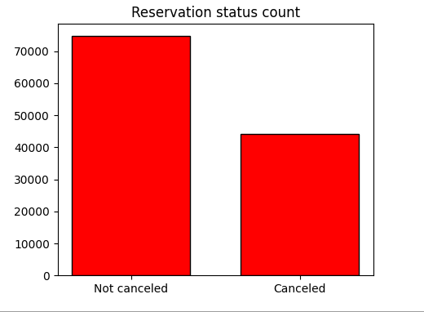

This bar graph shows the percentage of reservations that were canceled and those that were not canceled. Out of that 62.86% clients did not cancel their reservations and 37% clients canceled their reservations. This 37% cancellation significantly affects on hotel earnings.

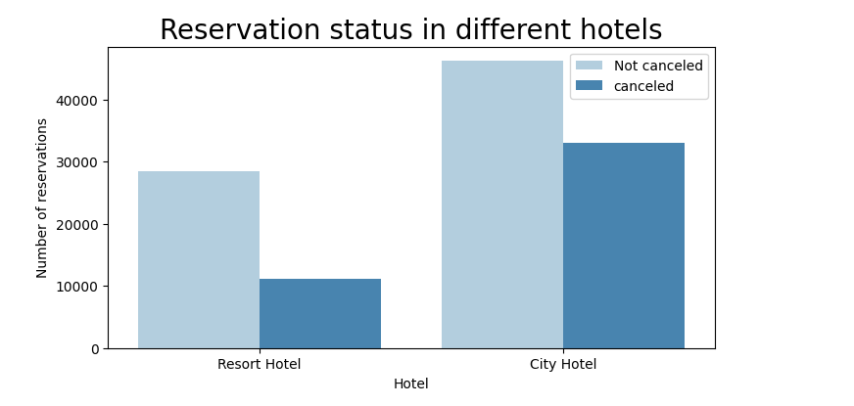

The reservation rate of city hotels is higher than the reservation rate of resort hotels. So it can be said that the demand of city hotels is more than resort hotels. The main reason for this is that resort hotels are more expensive than city hotels.

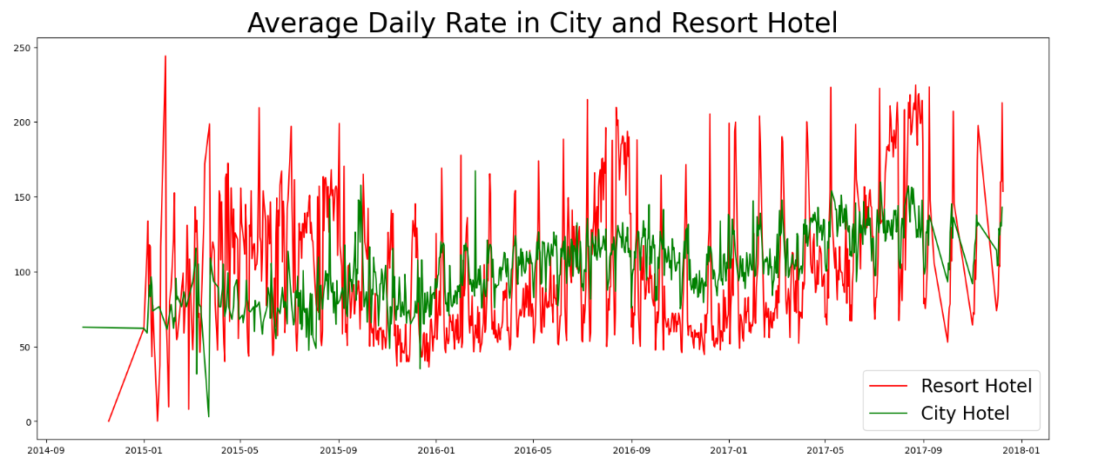

This line graph shows that city hotel rates are lower on certain days or holidays and even lower on other days. But resort hotel rates go up on holidays or weekends and are higher than city hotels on other days too.

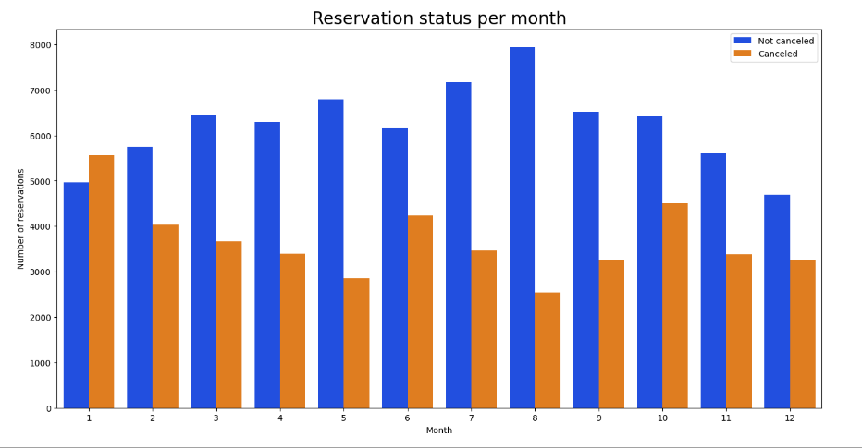

Created grouped bar graphs to analyze months with highest and lowest reservation levels by reservation status. Which shows that the month of August has the highest number of reservations as well as cancellation of large amount reservations. Again, the number of cancellations in the month of January is the highest.

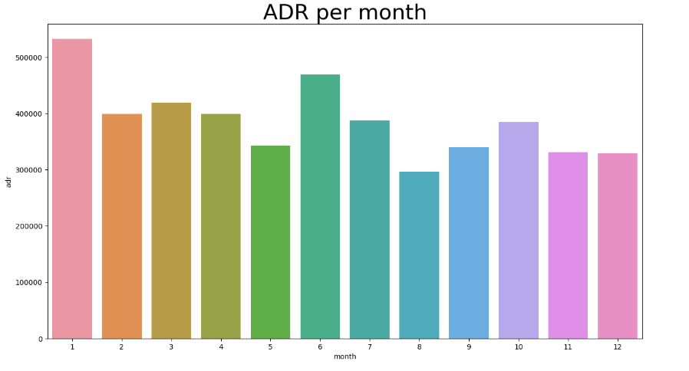

This bar graph shows that hotel cancellations were highest when hotel prices were high and cancellation rates were low when prices were low. This implies that, there is a significant relationship between hotel price and hotel cancellation.

**Cancelation rate in the based of the countries**

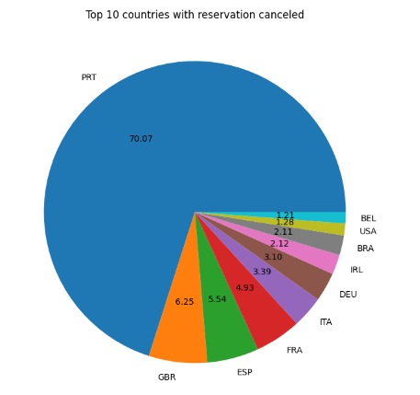

This pie chart shows that Portugal has the highest number of cancellation.

**Now let's see through which medium the clients book the most hotels . Is it coming from Direct or Groups, Online or Offline Travel Agents?**

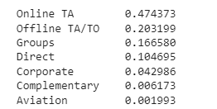

Around 47% of the clients come from online travel agencies.

whereas 16% come from groups

Only 10% of clients book hotels directly by visiting them and making reservations.

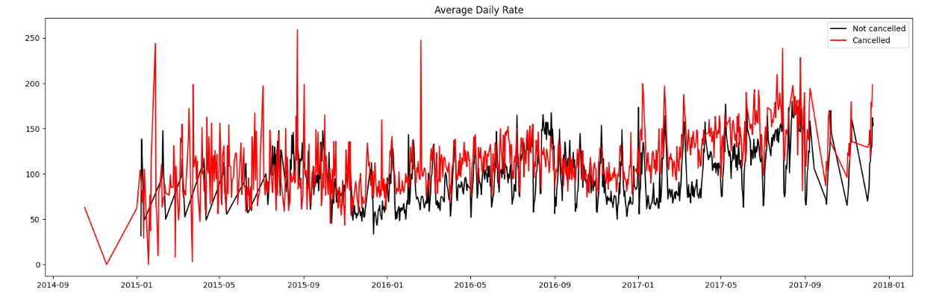

What this line chart shows is that reservations are canceled when the average daily rate is higher than what it would have been without cancellations. From all the above analysis it is clear that higher prices lead to higher cancellations.

**Suggestions**

1. Reservation cancellations were highest when hotel rates were high. So hotels can change their pricing strategy and lower their rates based on location to reduce cancellation rates. They can also provide some discounts to the consumers.
2. As cancellation and non-cancellation ratio in resort hotels is higher in resort hotels than in city hotels. So hotels should offer reasonable discounts on room rates during weekends or holidays.
3. Hotels can do campaigns or advertising with the right price in January as cancellations are highest in January.
4. In order to reduce the cancellation rate they can mainly improve their hotel and their service quality in Portugal as cancellation rate is highest in Portugal.